**Kubernetes Architecture**

Container orchestration is a critical aspect of modern software deployment and management, particularly in cloud-native environments. Kubernetes (often abbreviated as K8s) is one of the most prominent and widely adopted platforms for container orchestration. Below is an overview of container orchestration and how Kubernetes facilitates this process.

Kubernetes is a powerful open-source system for managing containerized applications across a cluster of machines. It provides mechanisms for deployment, maintenance, and scaling of applications. To understand how Kubernetes works, it's essential to grasp its architecture, which is composed of several key components:

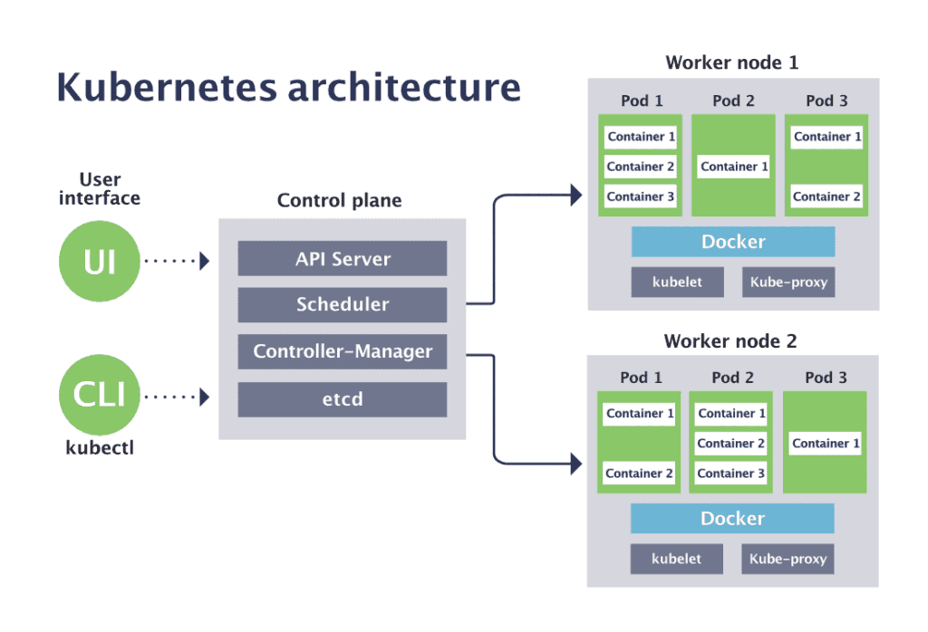

**Fig 1: Kubernetes Architecture**

1. **Master Node (Control Plane)**

The master node is responsible for managing the Kubernetes cluster. It consists of several components:

* **kube-apiserver:** This is the front-end for the Kubernetes control plane. It exposes the Kubernetes API and is the central hub for all interactions with the cluster.
* **kube-scheduler:** Watches for newly created Pods that have no assigned node and selects a node for them to run on based on resource availability and other constraints.
* **kube-controller-manager:** Runs controllers to regulate the state of the cluster. Each controller watches the shared state of the cluster through the API server and makes changes to move the current state towards the desired state.
* **etcd:** A consistent and highly available key-value store used as Kubernetes' backing store for all cluster data.

1. **Worker Nodes**

Worker nodes are the machines where application workloads are deployed. Each worker node runs several components to manage the pods running on them:

* **kubelet:** An agent that runs on each node in the cluster. It ensures that containers are running in a pod. The kubelet takes a set of PodSpecs and ensures that the described containers are running and healthy.
* **kube-proxy:** Maintains network rules on nodes. These network rules allow network communication to your pods from network sessions inside or outside of your cluster.
* **Container Runtime:** The software responsible for running containers. Kubernetes supports several runtimes, such as Docker, containerd, and CRI-O.